Company Information

 | Directors
 | Executive Directors:  Mr. Cai Lai Xing (Chairman)  Mr. Chen Jin Bang (Vice-Chairman and President)  Mr. Zhu Shi Xiong  Mr. Cao Fu Kang  Mr. Chen Wei Shu ¹(Managing Director)  Mr. Zhuo Fu Min ²(Deputy Managing Director)  Mr. Lu Da Yong (Deputy Managing Director)  Mr. Li Wei Da (Deputy Managing Director)  Mr. Wen Song Quan  Mr. Ge Wen Yao  Mr. Huang Yan Zheng  Non-executive Directors:  Sir Lee Quo Wei  Mr. Leung Chun Ying  Dr. Woo Chia-Wei  Dr. Lo Ka Shui  Mr. Lee Yeh Kwong, Charles  Mr. Leung Pak To, Francis  Company Secretary  Mr. Leung Lin Cheong, Roger  MBA, FCMA, FCIS, AHKSA  Authorised Representatives  Mr. Zhuo Fu Min  Mr. Leung Lin Cheong, Roger  Auditors  Deloitte Touche Tahmatsu | Legal Advisers  Woo, Kwan, Lee & Lo  Skadden, Arps, Slate, Meagher & Flom  Lee & Partners Law Offices  Principal Bankers  Bank of China  Bank of Communications  BHF Bank of Germany  Chiyu Bank Corporation Limited  Hang Seng Bank Limited  Kincheng Banking Corporation  Nanyang Commercial Bank Limited  Po Sang Bank Limited  The China and South Sea Bank Limited  The China State Bank Limited  The Dai-Ichi Kangyo Bank Limited  The Hongkong and Shanghai Banking Corporation Limited  The Kwangtung Provincial Bank  The Yien Yieh Commercial Bank Limited  Agricultural Bank of China, Shanghai Branch  Bank of Communications, Shanghai Branch  Industrial & Commercial Bank of China, Shanghai Branch  Pudong Development Bank  Registered Office  26/F., Harcourt House,  39 Gloucester Road, Wanchai, Hang Kong.  Share Registrars and Transfer Office  Secretaries Limited  5th Floor, Wing On Centre,  111 Connaught Road Central, Hong Kong
¹Appointed President on April 9, 1997
²Appointed Managing Director on April 9, 1997

Directors and Senior Management Profile
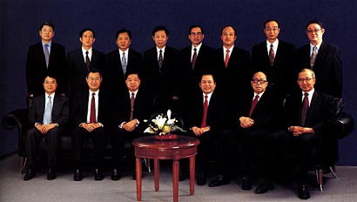
(Front row, from left):
Francis Leung, Woo Chia-Wei, Chen Jin Bang, Cai Lai Xing, Sir Lee Quo Wei, Lo Ka Shui;
(Back row, from left):
Lu Da Yong, Li Wei Da, Cao Fu Kang, Zhu Shi Xiong, Chen Wei Shu, Zhuo Fu Min,
Wen Song Quan, Ge Wen Yao.
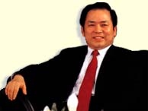
Chairman's Statement
The Board of Directors has pleasure in announcing that the audited consolidated profit attributable to shareholders for the period from 9th January 1996 to 31st December 1996 amounted to HK$247,033,000. The pro forma audited consolidated profit attributable to shareholders for the period ended 31st December 1996 amounted to HK$360,415,000 which is higher than the profit forecast as mentioned in the prospectus for listing by 16%.
On 17th May 1996, the Company has completed a reorganisation scheme and became a public company whose shares were then listed on The Stock Exchange of Hong Kong Limited on 30th May 1996. The Group has through its subsidiary companies, Nany ang Brothers Tobacco Co. Ltd. ("Nanyang Tobacco"), The Wing Fat Printing Co., Lt d. ("Wing Fat Printing"), Shanghai Sunve Pharmaceutical Co., Ltd. ("Sunve Pharmaceutical") and Shanghai Jahwa Co., Ltd. ("Shanghai Jahwa") engaged in the businesses of manufacture, distribution and sale of cigarettes, packaging materials and printed products, pharmaceutical products, and personal care and cosmetics products. After the formation of Shanghai Xiafei Daily Chemical Co., Ltd. ("Shanghai Xiafei") in September and the assets injection by the end of 1996, the number of operating entities has been increased to 10. The names of the respective additional entities are: Shanghai Bright Dairy and Food Co. Ltd. ("Shanghai Dairy"), Shanghai Huizhong Automotive Manufacturing Co. Ltd. ("Shanghai Huizhong"), Shanghai Transportation Electric Co., Ltd. ("Shanghai Transportation Electric"), Shanghai Orient Shopping Centre Ltd. ("Orient Shopping Centre"), Shanghai Yanan Road Elevated Road Development Co., Ltd. ("Yanan Road Elevated Road").
Chairman's Statement - Review of Business Strategy
The successful listing of the shares of the Company provided economic and social benefits and enhanced the respective strengths of the Group's operations in Shanghai and Hong Kong.
Several prominent changes have taken place since the date of listing:-
- The Company's net tangible assets had grown to around HK$4 billion from approximately HK$1,600 million representing more than 150% increment.
- The profit generation from the Group's Shanghai-based business increased significantly and accordingly the proportion of the Hong Kong operation was reducing.
- The proportion of the profit contribution by the cigarette business had been adjusted downward from the original share of 80%.
- With the injection of the Yanan Road Elevated Road Project and the Orient Shopping Centre, the business structure has gradually changed from an entirely industrial business to a diversified business.
As summarized above, the Shanghai-based business concept of Shanghai Industrial Holdings Limited has basically been formed.
Business Review
Since the five operating entities, which were acquired by the Group at the end of 1996, have not been taken into account, therefore, the proportion of the cigarette's business is the largest during the period under review. It contributed most of the profit and cash flow to the group. With regard to the cosmetics and personal care products business, in view of the huge consumer population and the improving living standard, the prospect of this industry is promising. During the period, the Company acquired a 51% interest in Shanghai Xiafei whose business supplemented the business of Shanghai Jahwa enabling the Group to cover almost all market segments. Furthermore, the Group faced great difficulties in the pharmaceutical industry, particularly the prices for Vitamin C continued to drop. As a result, neither sales nor profits of the pharmaceutical business met expectations.
The Group had extended the range of consumer products to include certain daily necessities - the production and sale of bottled milk.
As disclosed in the listing prospectus, the Company will streamline the market penetration to the six major industries in Shanghai particularly the automobile manufacturing. At the end of the year, the Company acquired a 50% interest in Shanghai Huizhong and a 30% interest in Shanghai Transportation Electric. These two companies are engaged in the manufacturing and sale of automobile components to the major automobile manufacturers in Shanghai.
As part of the business diversification strategy, the Company engaged in retail business through the holding of a 51% interest in Shanghai Orient Shopping Centre whose principal activities are the sale of high- to middle-end consumer products. In respect of the infrastructure business, at the end of the year, the Group acquired a 50.2% interest in Yanan Road Elevated Road Project. The construction of the western section on the Yanan Road Elevated Highway was completed. This section is the only highway that connects the Hongqiao International Airport to downtown Shanghai.
All the eight operating entities acquired by the Group are well-known in Shanghai and having significant market places in the respective industries.
Chairman's Statement - Organisational Structure and Management
The Hong Kong and Shanghai businesses are being run on a parallel basis. The Group is emphasising the professionalism of its management and increasing the transparency of its activities.
The management team comprises local officers, who posses PRC-oriented different skills and backgrounds and professionals recruited in Hong Kong. To enhance the relations between various parts of the Group, a Business Management Department and an internal audit function are established to streamline the management function.
Prospects
The Company now has 10 operating entities in four different markets: consumer products; retailing; infrastructure; and the manufacturing of automobile components. In view of the consistent growth of the Shanghai economy, the Board is confident that the performance of the Company's respective businesses will continue to grow.
The business diversification in Shanghai and the Yangtze Delta Region is part of a long term strategy of the Company. Apart from expanding the existing businesses, the Company will also increase its investment in industries that have been identified by the Government as development priorities and which have been given preferential status.
The Company's parent company, Shanghai Industrial Investment (Holdings) Company Limited is the "Window" company established for the Shanghai Municipal People's Government. The parent company operates over 190 subsidiaries and associates having various investments and businesses within Shanghai. As and when appropriate opportunities arise, the Company will consider acquiring businesses from its parent company to strengthen its own business base.
The Company has, through its parent company, maintained special links with the Shanghai Government and this can assist the Company in seeking attractive investment opportunities in Shanghai. It is expected that shareholders will enjoy fruitful returns on their investment resulted from continuing economic growth of Shanghai. The Group has strategically diversified its business which can generate considerable return and stable cash flow. The Group's demand for quality management working to attain international standards will continue to increase. The corporate mission of Shanghai Industrial can be summed up as "Hong Kong base; Shanghai backing; enhancing links between Shanghai and Hong Kong". Businesses in Shanghai and Hong Kong will continue to diversify on a parallel basis. Emphasis will be placed on "by the linkage between Shanghai and Hong Kong to cover both PRC and Hong Kong markets".
Mr . Charles Yeh-Kwong Lee has resigned as Non-Executive Director of the Company effective 12th March 1997 and Mr. Leung Chun Ying will also resign as Non-Executive Director of the Company effective 31st March 1997 in view of their full devotion to public service. I would like to express sincere thanks and appreciation to their contribution to the establishment and development of the Group.
On behalf of all members of the Board, I would like to express our gratitude to shareholders for their support and to all staff of the Group for their hard work and contributions.
Hong Kong, 20th March 1997
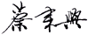
CAI LAI XING
Chairman

Business Structure
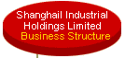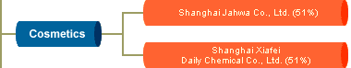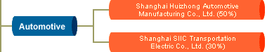

Business Structure
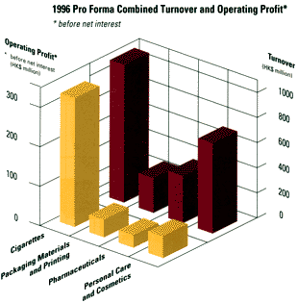
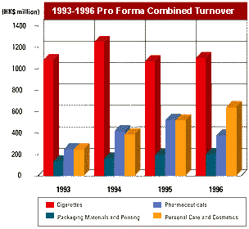

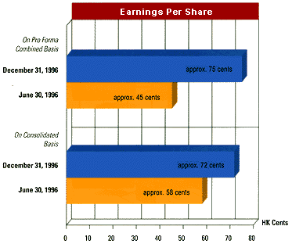
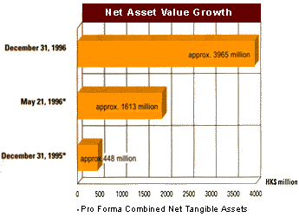
Consolidated Profit and Loss Account
FOR THE PERIOD FROM 9TH JANUARY, 1996
(DATE OF INCORPORATION) TO 31ST DECEMBER, 1996)
 | Consolidated  9.1.1996  to  31.12.1996 | Pro Forma  Combined  1.1.1996  to  31.12.1996
 | HK$'000 | HK$'000
TURNOVER | 1,317,412 | 2,200,631
OPERATING PROFIT
Continuing operations before exceptional item | 269,474 | 410,302
Exceptional item | 17,637 | 17,637
 | 287,111 | 427,939
SHARE OF LOSSES OF ASSOCIATED COMPANIES | (2,673) | (189)
PROFIT FROM ORDINARY ACTIVITIES BEFORE TAXATION | 284,438 | 427,750
TAXATION | 24,532 | 46,489
PROFIT BEFORE MINORITY INTERESTS | 259,906 | 381,261
MINORITY INTERESTS | 12,873 | 20,846
PROFIT FOR THE PERIOD/YEAR | 247,033 | 360,415
DIVIDEND | 90,023 | 90,023
EARNINGS PER SHARE  - Basic | 72 cents | 75 cents

Consolidated Balance Sheet (At 31st December, 1998)

 |  | 1998  HK$'000 | 1997  HK$'000
 | FIXED ASSETS | 1,327,598 | 711,177
 | BRAND NAMES | 37,956 | 39,743
 | INTERESTS IN JOINTLY CONTROLLED ENTITIES | 1,370,467 | 1,204,798
 | INTERESTS IN ASSOCIATED COMPANIES | 204,727 | 170,401
 | OTHER LONG-TERM INVESTMENTS | 6,587,538 | 6,686,095
 | DEPOSITS PAID ON ACQUISITION OF FIXED ASSETS | 64,758 | 195,772
 | NET CURRENT ASSETS | 4,199,390 | 3,282,909
 |  | 13,792,434 | 12,290,895
 | Financed by:
 | SHARE CAPITAL | 88,132 | 83,732
 | RESERVES | 10,759,315 | 9,343,557
 | SHAREHOLDERS' FUNDS | 10,847,447 | 9,427,289
 | MINORITY INTERESTS | 318,630 | 247,274
 | LOAN FROM ULTIMATE HOLDING COMPANY | 193,500 | 193,500
 | OTHER LONG-TERM LOANS | 2,359,766 | 2,385,532
 | DEFERRED TAXATION | 73,091 | 37,300
 |  | 13,792,434 | 12,290,895

The Year 2000 Computer Issue


With regard to the year 2000 computer issue, the Group has carried out a further assessment of the systems of all its member companies. The assessment included testing hardware and software, and upgrading or replacing equipment that had potential problems. Rigourous testing, including inspections and sampling checks, with the assistance of independent consultants, is continuing. To date, no problems involving the year 2000 computer issue have been detected that will have any material impact on the production, sales and operations of any Group company. Preventive measures are scheduled to be completed in mid-1999. Certain avoidance work will be carried out by the end of the third quarter of 1999. The total cost of the process has been budgeted and accounted for as an ordinary item. The Group believes that the year 2000 computer issue will have no material impact on the operations of the Group.

